LAB RECORD
COMPILER DESIGN
19CSE401



Amrita School of Computing
Amrita Vishwa Vidyapeetham
Chennai – 601 103, Tamil Nadu, India.

BONAFIDE CERTIFICATE

University Reg. No : _______CH.EN.U4CSE22043______

This is to certify that this is a bonafide record work done by
Miss.________Palavajjhala Neha Madhu Manasa_________________ studying
B.Tech__________4th Year_____________________

INDEX

Experiment Number | Topic Name | Date | Page no
01 | Implementation of Lexical Analyzer Using Lex Tool | 7-07-2025 | 4
02 | Program to eliminate left recursion and factoring from the given grammar | 21-07-2025 | 9
03 | Implementation of LL(1) parsing | 11-09-2025 | 12
04 | Parser Generation using YACC | 25-09-2025 | 14
05 | Implementation of Symbol Table | 1-09-2025 | 15
06 | Implementation of Intermediate Code Generation | 8-09-2025 | 17
07 | Implementation of Code Optimization Techniques | 15-09-2025 | 19
08 | Implementation of Target code generation | 22-09-2025 | 21

Exercise 1

1.
Aim: LEX program to count the number of vowels and consonants in a given string
Code:

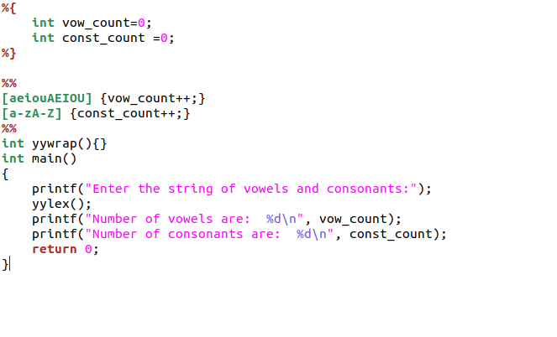

Output :

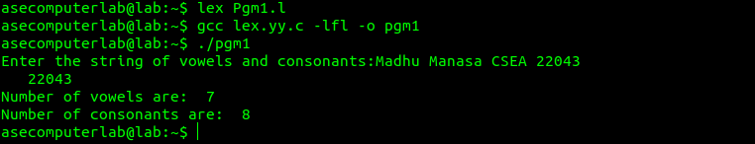

2.
Aim: Lex code for password validation
Code:

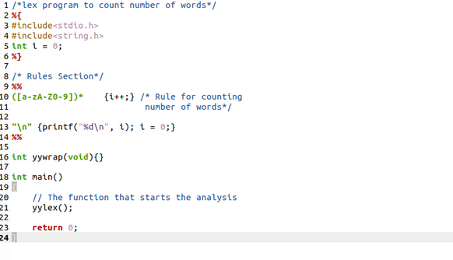

Output :

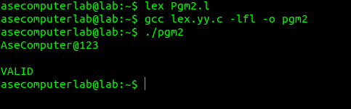

3.
Aim: Lex program to count the number of lines, spaces and tabs
Code :

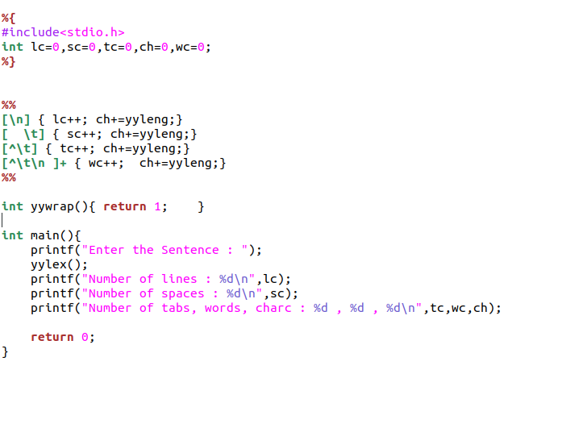
Output :

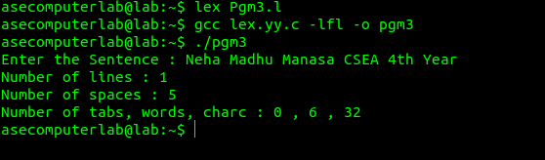

4.
Aim: Lex Program to Identify and Count Positive and Negative Numbers
Code:

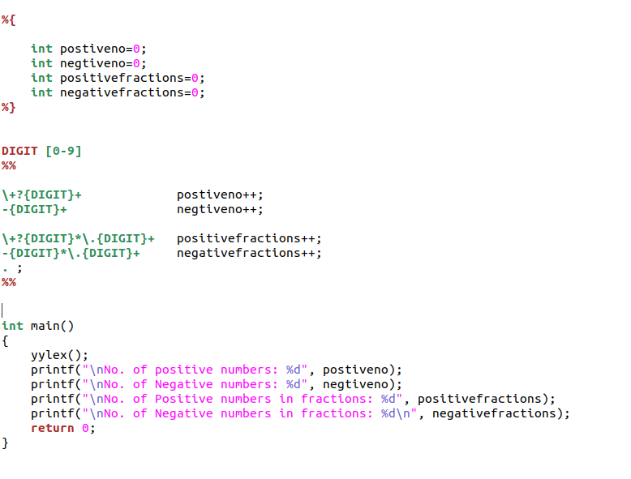

Output :

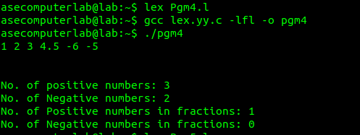

5.
Aim: Lex program to identify the identifier
Code:
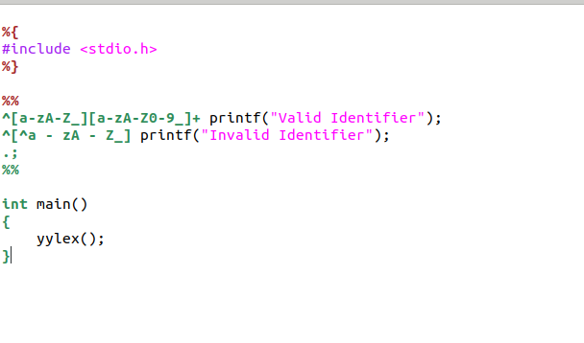

Output :

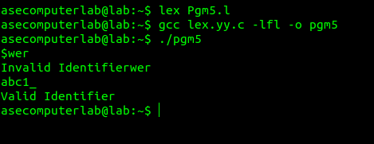

Exercise 2

- Aim: To implement eliminate left recursion and left factoring from the given grammar using C program.

Algorithm:
Left Factoring:
- Start the processes by getting the grammar and assigning it to the appropriate
variables
- Find the common terminal and non-terminal elements and assign them in a
separate grammar
- Display the new and modified grammar.

Code:
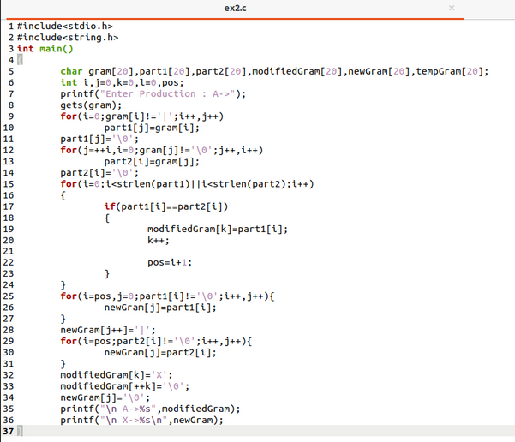

Output:
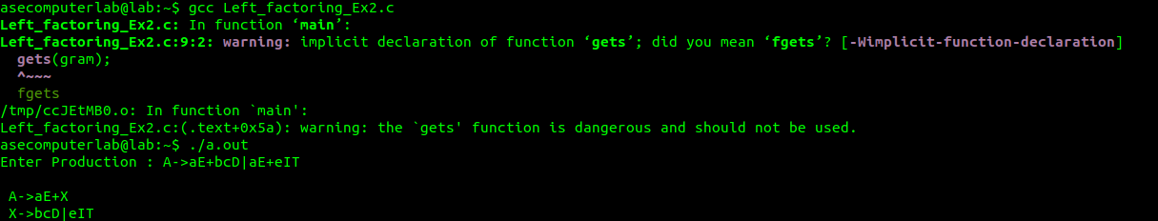

Left recursion:
- Aim: To implement left recursion using C.

Algorithm:
- Start the processes by getting the grammar and assigning it to the appropriate
variables.
- Check if the given grammar has left recursion.
- Identify the alpha and beta elements in the production.
- Print the output according to the formula to remove left recursion

Code:
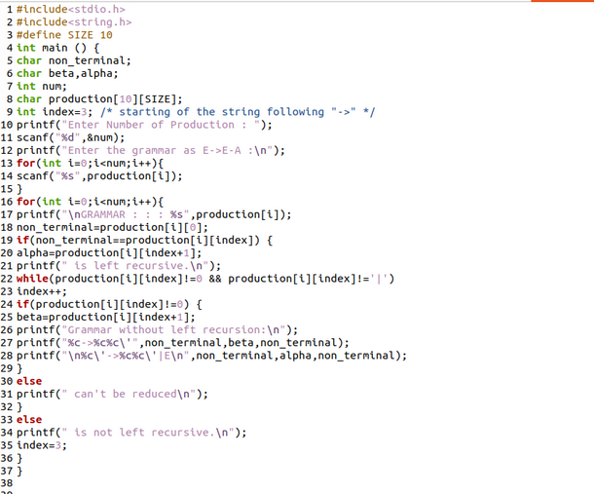

Output:
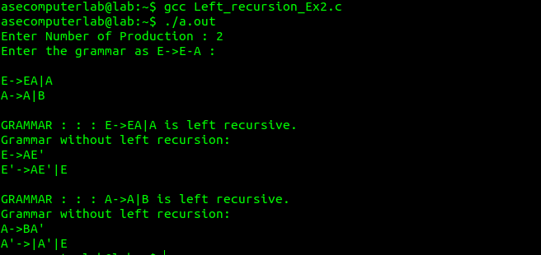

Result: The program to implement left factoring and left recursion has been successfully executed.

Exercise 3

Aim: To implement LL(1) parsing using C program.
Algorithm:
1) Read the input string.
2) Using predictive parsing table parse the given input using stack.
3) If stack [i] matches with token input string pop the token else shift it repeat the
process until it reaches to $.
Code :
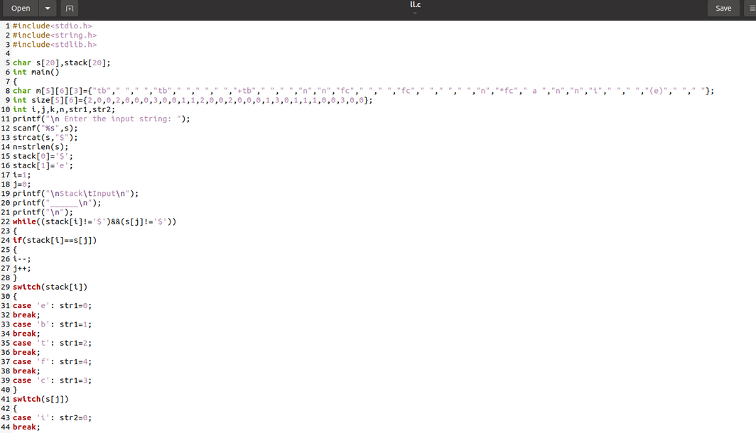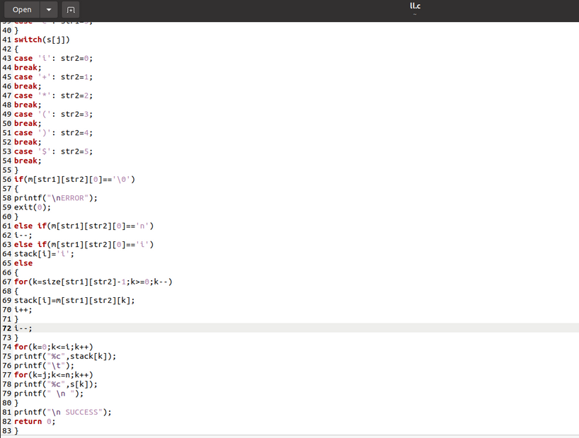
Output :
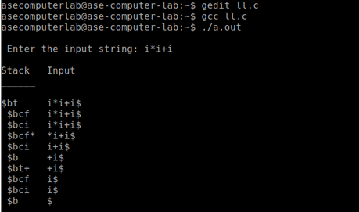

Exercise 4
Aim: To write a program in YACC for parser generation.
Algorithm:
- Get the input from the user and Parse it token by token.
- First identify the valid inputs that can be given for a program.
- Define the precedence and the associativity of various operators like +,-,/,* etc.
- Write codes for saving the answer into memory and displaying the result on the screen.
- Write codes for performing various arithmetic operations.
- Display the possible Error message that can be associated with this calculation.
- Display the output on the screen else display the error message on the screen
Code :
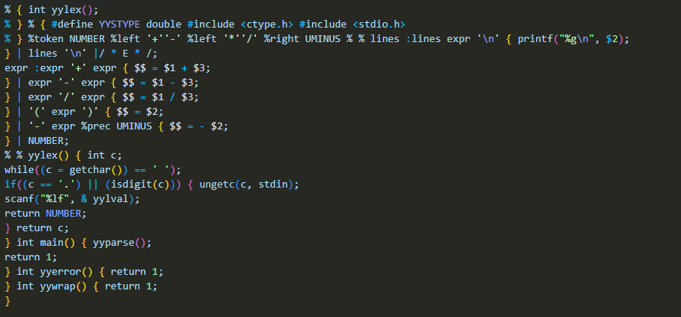
Output :
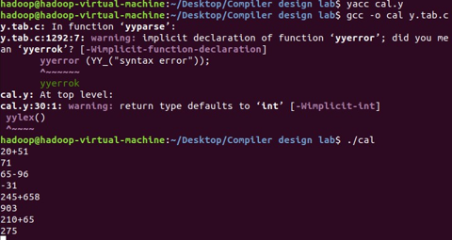

Result: Thus the program in YACC for parser generation has been executed successfully.
Exercise 5

Aim: To implement Symbol Table.
Algorithm:
- Start the Program.
- Get the input from the user with the terminating symbol ‘$’.
- Allocate memory for the variable by dynamic memory allocation function.
- If the next character of the symbol is an operator then only the memory is allocated.
- While reading, the input symbol is inserted into symbol table along with its memory address.
- The steps are repeated till “$” is reached.
- To reach a variable, enter the variable to the searched and symbol table has been
- Checked for corresponding variable, the variable along its address is displayed as result.
- Stop the program
Code :
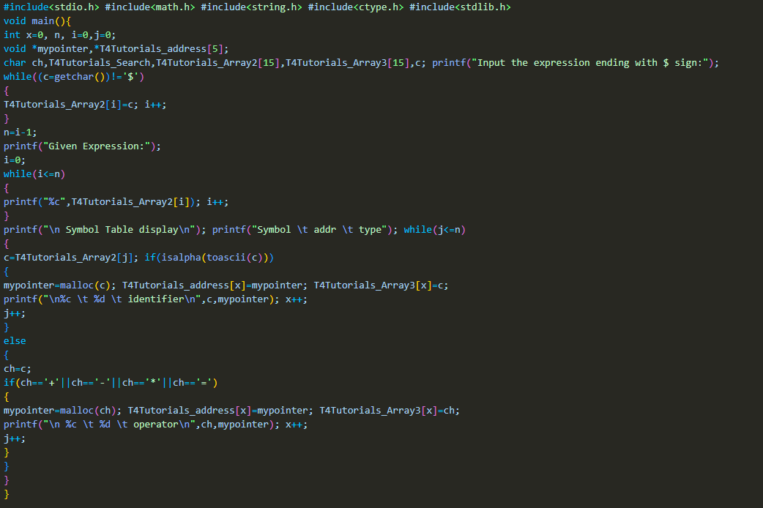

Output :
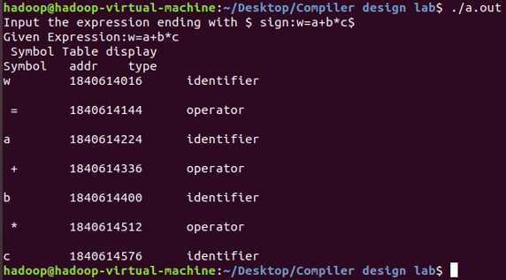

Result: Thus the program to implement symbol table has been executed successfully.

Exercise 6

Aim: To implementation of intermediate code generation.
Algorithm:
- Take the parse tree tokens from the syntax analyser.
- Generate intermediate code using temp variable
- Assign the final temp variable to initial variable
Code :
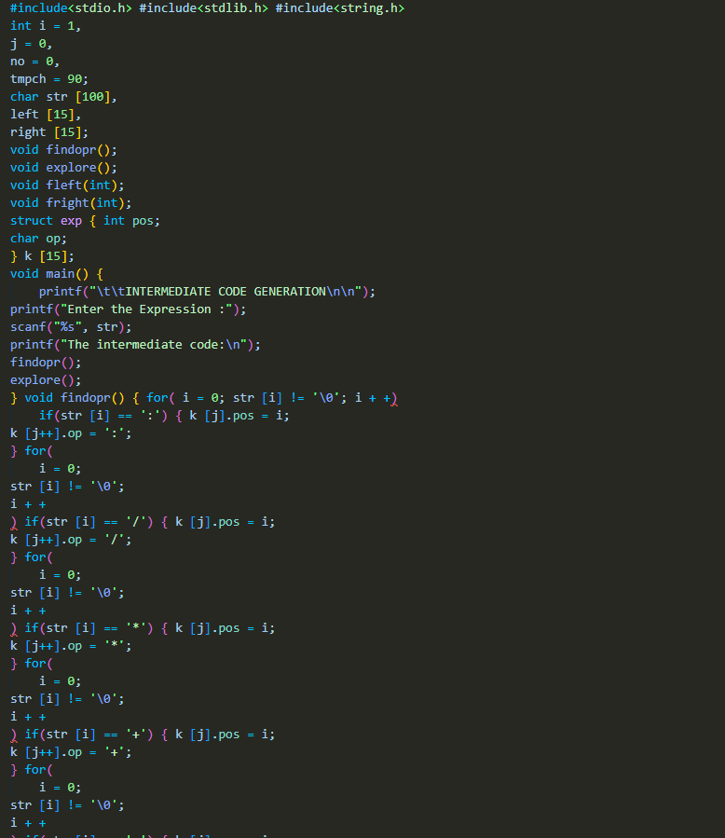
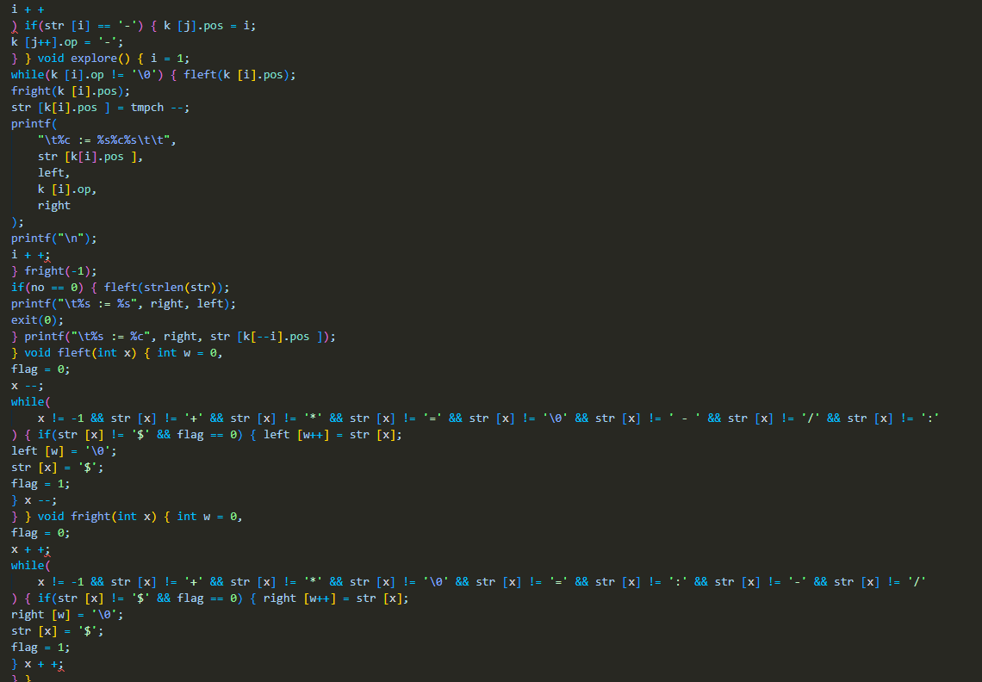
Output :
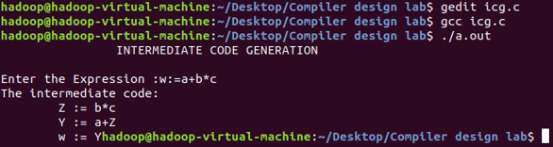

Result: Thus, the program to implement intermediate code generation has been executed successfully.

Exercise 7

Aim: To implementation of Code Optimization Techniques
Algorithm:
- Start the program
- Declare the variables and functions.
- Enter the expression and state it in the variable a, b, c.
- Calculate the variables b & c with ‘temp’ and store it in f1 and f2.
- If(f1=null && f2=null) then expression could not be optimized.
- Print the results.
- Stop the program.
Code :
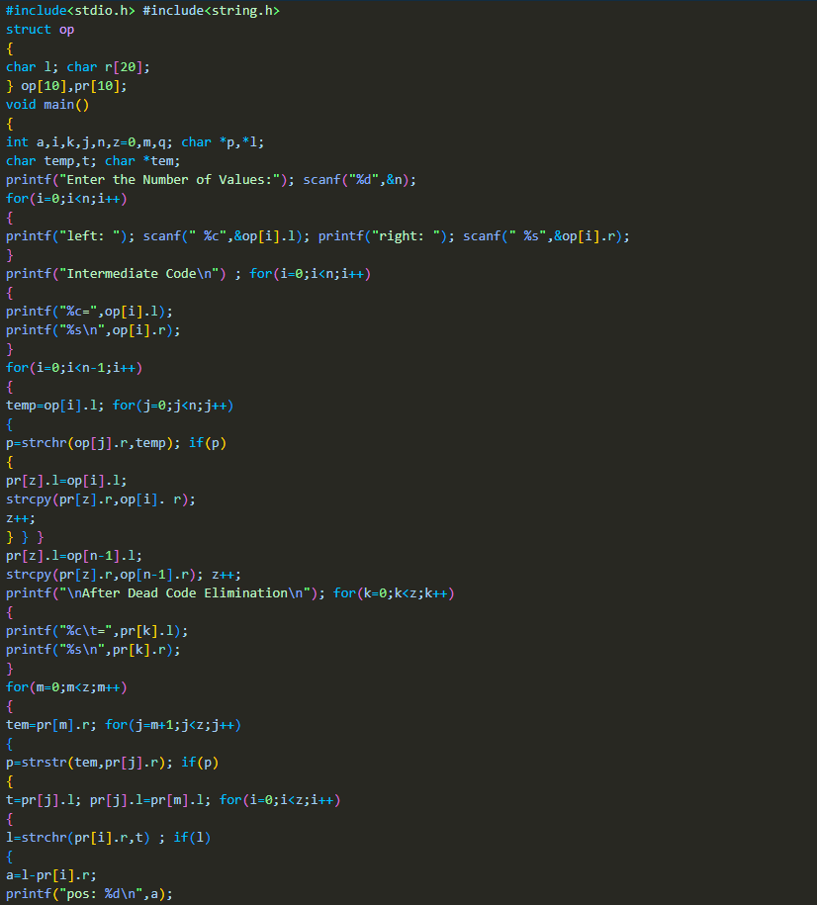
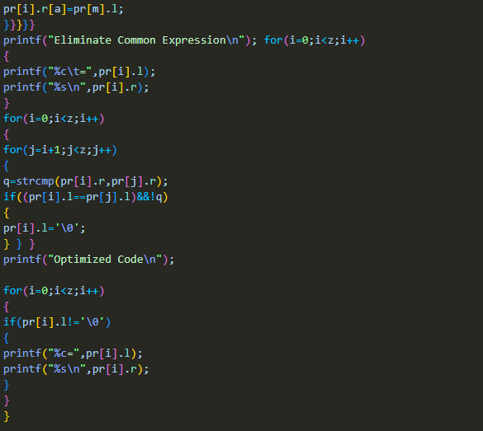
Output :
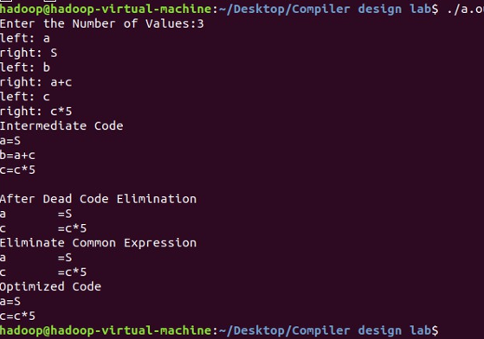
Result: Thus, the program to implement code optimization has been executed successfully.

Exercise 8

Aim: To write a program that implements the target code generation
Algorithm:
- Read input string
- Consider each input string and convert it to machine code instructions using switch case
- Load the input variables into new variables as operands and display them using “load”
- With the help of arithmetic operation, we will display arithmetic operations like add, sub, div, mul for the respective operations in switch case
- Generate 3 address code for each input variable.
- If ‘=‘ is seen as arithmetic operation, then store the result in a variable and display it with “store”.
- Repeat this for each line in the input string.
- Display the output which gives a transformed input string of assembly language code.
Code :
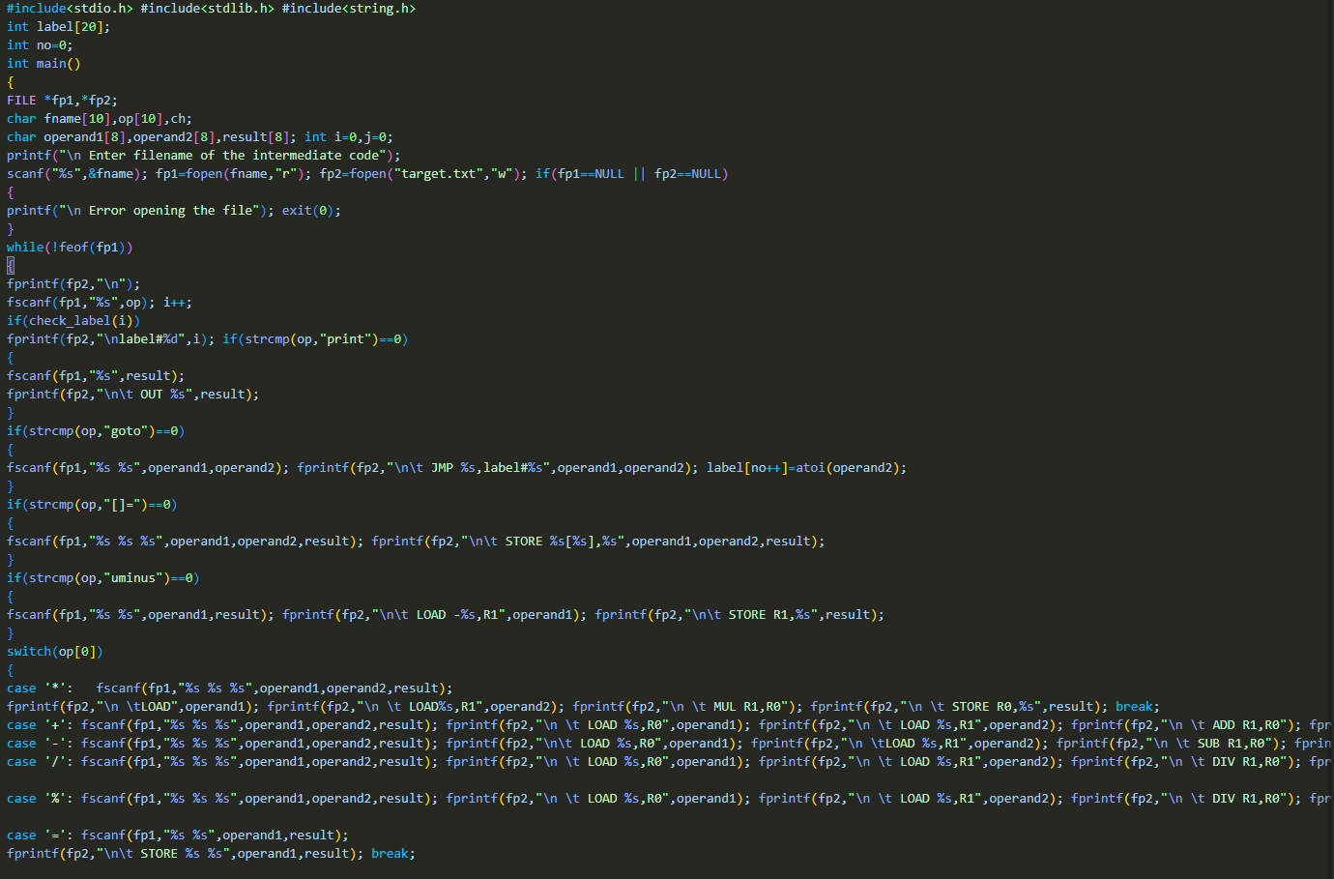

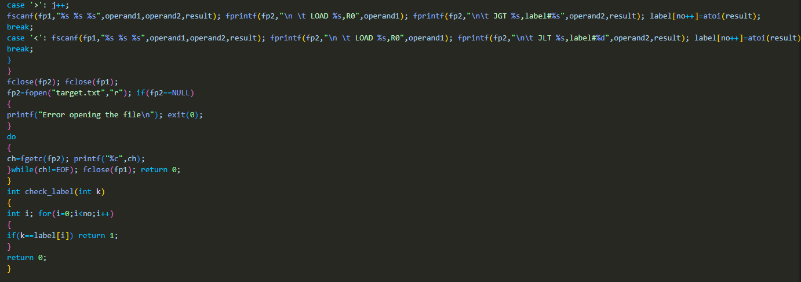
Output :
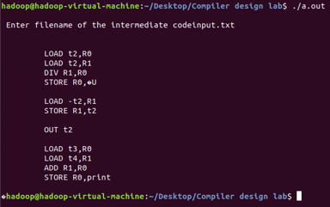

Result: Thus, the program to implement target code generation has been successfully executed.

